Yolanda Brown

Module5.2

Mysql functions:

* 1st) Find_In_Set- allows one to locate the position of a string separated by commas.

This is very similar to windows find search tool.

🡪Reason used: This maybe used in case you want to find the position

of the data to extract it. For example, let’s say we have a list of car models

and we want to pull the list of car models who name start with an m,

we can use the find and set to jump to the M section.

🡪 ALIAS & FIND_IN_SET

W3 Schools Database https://www.w3schools.com/mysql/trymysql.asp?filename=trysql_select_alias_column0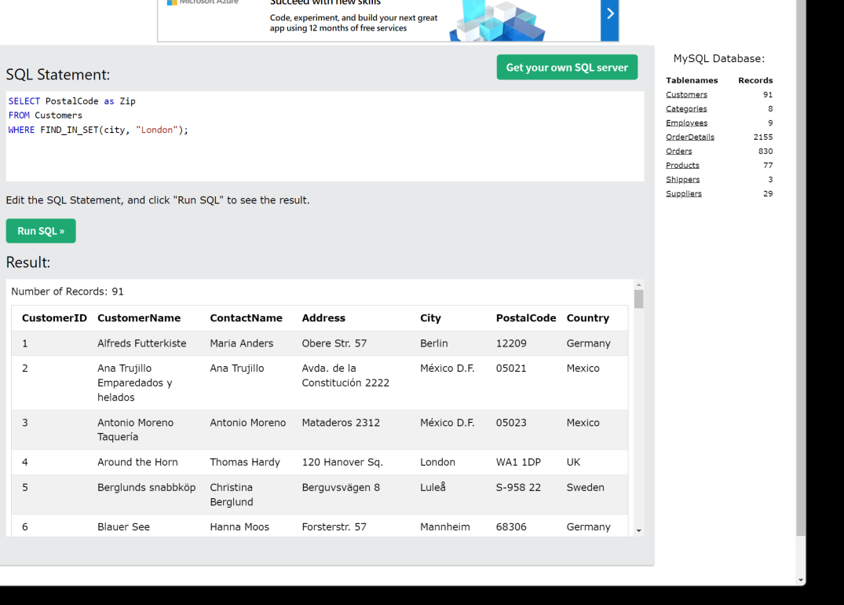

* AFTER THE QUERY-FIND_IN_SET
* 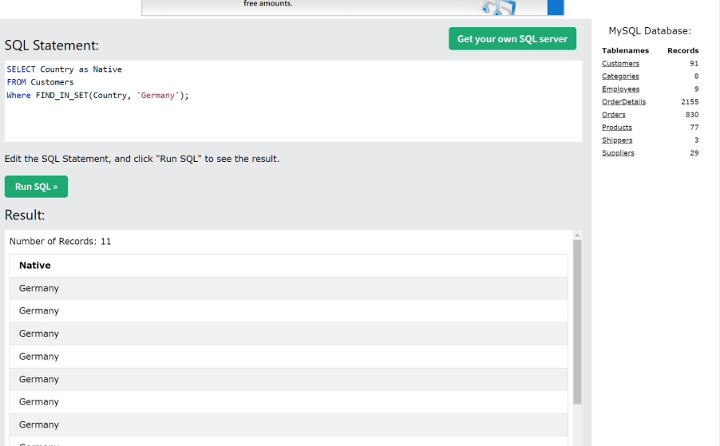
* 2nd- the Concat() function adds 2 or more Strings together
* Reason used- to put 2 of more strings together for output

-For example FirstName and Last Name or address

Example: W3 Table- Employees

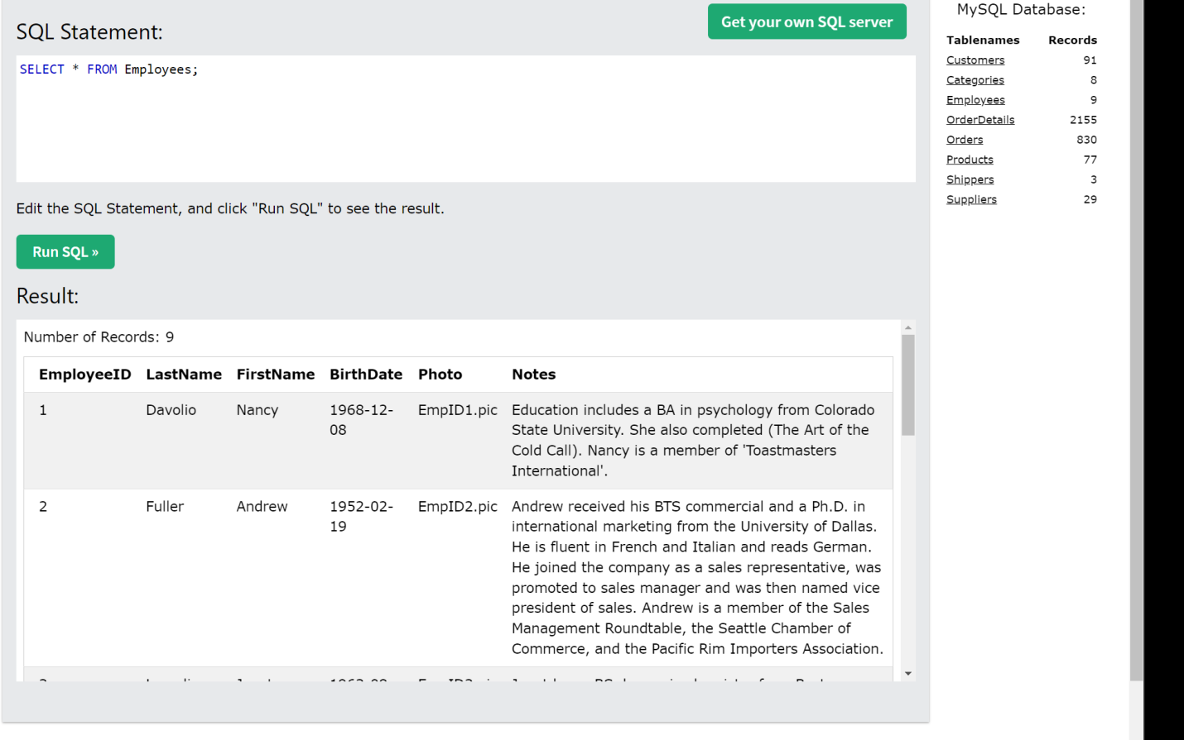

AFTER THE QUERY CONCAT:

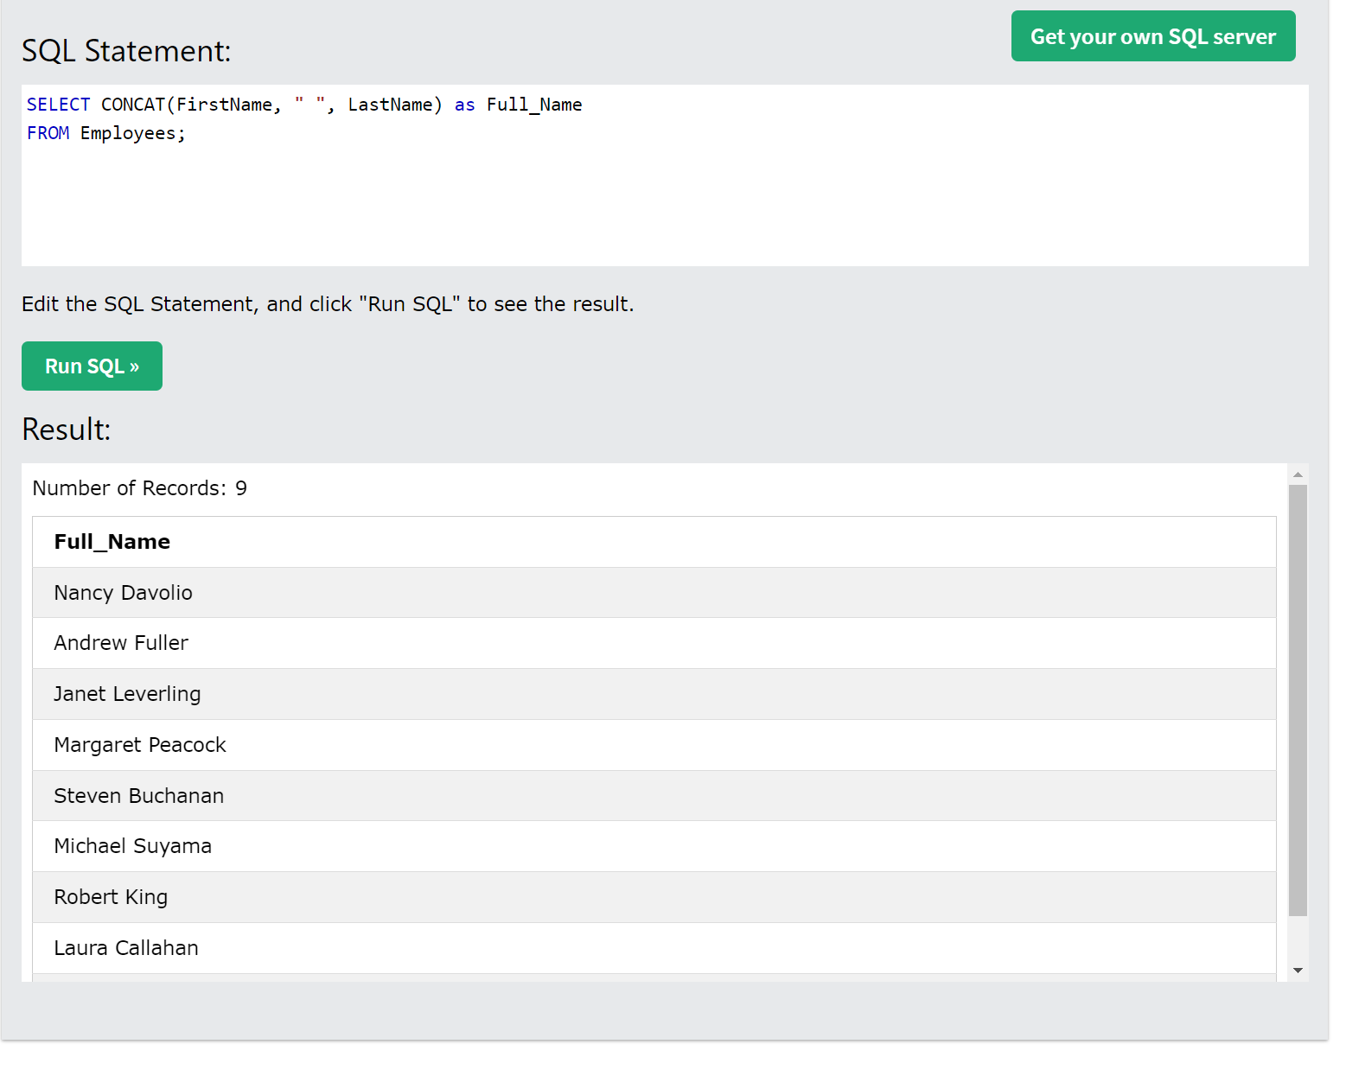

* 3) UCASE Function- converts string to uppercase

🡪Reason: Someone may have accidently keyed the data in wrong ie months and

They were suppose to be all capital letters

For example:

W3 –Shippers before the UCASE Has all lower case

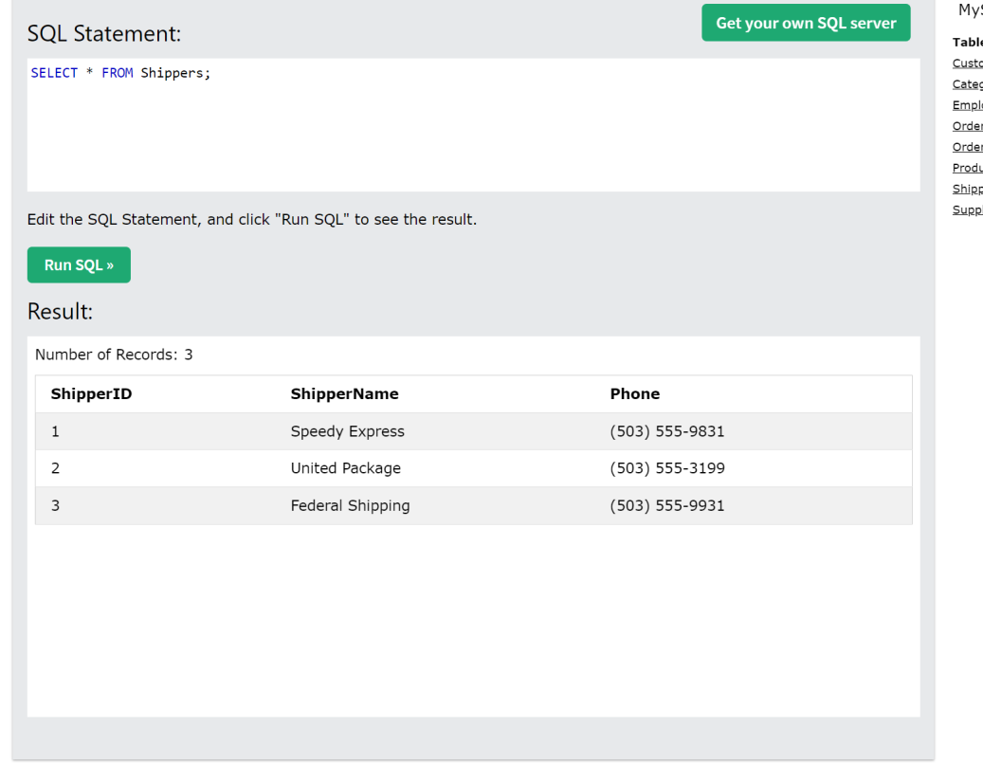

AFTER THE QUERY UCASE + Alias

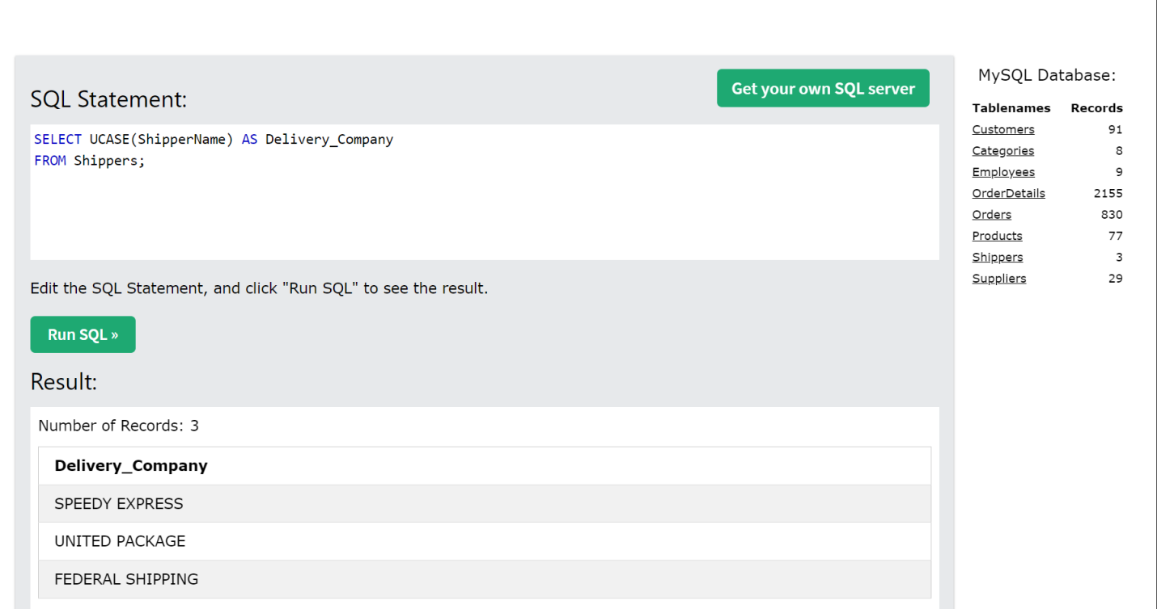

Sources:

https://www.w3schools.com/sql/func_mysql_find_in_set.asp